Weight Management AccuRx Template

We know how hard it is to lose weight and to keep it off.
Some of us find it more difficult than others, and there is good reason for this including the 1,100 genes already found that influence what weight we are
People living with Obesity do NOT lack self control – they are in fact, often, the most self-disciplined of people!
There iis no one way to lose weight for all people
We hope this leaflet is helpful

Weight Management Leaflet

compiled by Dr Nadia Kingsley, July 2026, based on a NB Medical “Obesity and Weight Management” Course

Dr Kingsley says –At Plas Ffynnon Medical Centre we are deeply unhappy with how little we have to offer people living with obesity. We hope this leaflet helps a little. It comes with a HUGE disclaimer! I am no expert on obesity and weight management and the following is sourced from reliable sources but is and can never be a complete resource. But hopefully anyone living with obesity will feel a little more seen, a little more heard, and maybe find some useful tips in here

First, some facts I learned on the course:

Obesity is a chronic and relapsing disease marked by an abnormal or excess accumulation of body fat that presents a risk to health

BMI is still being used and is essential for NHS referrals into Obesity Management
But Height to waist circumference ratio is much more important - as it is a measure of visceral fat which is the fat that causes health implications compared to subcutaneous fat, especially if BMI < 35 – so we all now have a 200 cm tape measure, ready to measure this.
To measure this yourself:
Measure waist half way between bottom of ribs and top of superior border iliac crest
Basically if your waist circumference is less than half your height you have the least risk to your health – both in children and adults
0.4 – 0.49 = healthy
0.5 to 0.59 = increased health risk
>0.6 further increase to health risk

There isn’t such a thing as puppy fat that they will grow out of
An eating together unit/society tend to have lower BMI
If you move from a place of food scarcity to food plenty BEWARE – you are likely to gain weight as eat more
Genetics can mean you are more likely to create visceral fat, may look skinny but higher risk
Try and keep a child that comes from a genetically obese family normal weight to teens which is when the genes mostly switch on

CAUSES OF OBESITY
Genetics
Currently there are 1,100 genes known to be related to obesity

Class 4/5 is rare in under 2yrs old – refer esp if insatiable appetite, cupboards locked, will self harm if not fed eg Prader-Willi syndrome

Most have polygenetic obesity:-

Pathways in brain that affect hunger and satiety and also those that change behaviours in people living with obesity are found to get higher endorphin rush/reward from food, food choices, food-seeking behaviour, response to food cues like ads
MRIs show reward centres lighting up when shown food – this is dampened by obesity medicines

Stress
increased cortisol because noisy environment, worries about finances – increases cortisol which increases putting down of visceral fat

Food choices is a privilege – many have no kitchen, tiny fridge, no freezer, live where fast food available cheaper and fills family, shift work, night work – hormones affect brain and what food is available

Metabolic set point theory – after 5 yrs of losing weight only 7% will have kept weight off – the rest will have regained/ put more weight on – body protecting us from future “famines”

VISCERAL FAT

excretes loads of inflammatory cells, relate to obesity-related cancers, insulin resistance, atherosclerosis, sore joints even fingers and elbows
CRP/ESR often slightly raised in those with obesity

Psychological factors – MH, coping strategy, low self esteem, sexual abuse/ childhood abuse OFTEN, disordered eating – binge, night time eating, secret eating

Behavioural factors – sedentary job, shift work, stress

Affecting babies in pregnancy – weight pre-pregnancy is important but more important is significant increase in weight early in pregnancy; so stopping miunjaro as getting pregnant has detrimental effect to baby; weight of dad at conception has effect

MEDICATIONS

I am afraid there are a lot of medications that we prescribe that can cause weight gain. We are all now equipped with the Canadian Obesity Guidelines that have a table of medications that are the worst offenders and their alternatives. We are happy to see if it is possible to change your medications – please make a routine telephone appointment – telling us that you want to look at weight gain medications. Here is the list. Obviously some of the medications on the list would require a discussion with your specialist rather than a GP – the ones in blue are the ones we can usually advise on:

Olanzapine
Mirtazapine
Diabetes meds – discuss just with Sister Caroline Bartram or Dr James Lindsay
Prednisolone
Tamoxifen
Beta blockers – including propranolol, atenolol, bisoprolol
Clonidine
Anticonvulsants
Depot contraception

Things that may you may find helpful
If you lose 5 to 10% of body weight this improves Blood Pressure, lipid, continence
If you lose 10 to 15% of body weight this improves sleep apnoea, reduces cancer and liver issues

But don’t be set up to fail – setting a lower target and maintaining it is a huge and better victory than quick weight loss. If you aim for a 5% weight reduction and stay there?.. there is still only a 1 in 7 chance of weight loss maintenance success in a year (and not because of poor self control – but because of all the other reasons above under causes of obesity)

It might be a good idea to have a set of blood tests if you haven’t had any recently – to check your liver, thyroid, diabetes status and your nutritional state in particular

Change to eating/ diet
There is no one eating plan that will work for everyone. Weight loss maintenance is the same/ equally difficult for all ways of eating
Your choice of eating/ diet going forwards needs to be safe, affordable, nutritionally adequate, culturally acceptable, and enjoyable!
Food tracking with an app- provides an awareness of what someone is putting in their mouth and this has been shown to help in losing weight does

Ultraprocessed food – they do have a link to obesity but they aren’t all equal – eg haribo, pop tarts have NO nutrition, they can affect satiety hormone and you get hungry quicker and don’t feel as full but they are affordable and quick and with some jobs they are all that is available – so choose the betteroption where possible

Activity

is always good for us
lots of good ideas free on youtube

A 5 part x 15 min podcast by Prof Giles Yeo on mounjaro and other weight loss medications
https://www.bbc.co.uk/sounds/play/m002r3kc

Zoe you tube with Prof Giles Yeo – what to count instead of counting calories https://www.youtube.com/watch?v=sTu3E2ccC_g

Big Birthas website - https://bigbirthas.co.uk/ a support group for women who are pregnant or trying to conceive whose BMI is 30 or more

All About Obesity Group website which is for patient and clinicians https://allaboutobesity.org/

We all know there are lots of reasons why it is difficult to eat healthily and to lose weight. The cost of food, the cost of fuel to prepare the food, the time it takes to prepare good food. Changing habits is a really big one. Exhaustion. Changing the whole family’s habits as well as your own – the list goes on. But don’t give up!

You are important
And your health now and in the future is important.

The fantastic thing is that there is now a lot of free help online
And that a change in your diet can make a huge impact both on your physical AND mental health
And you can actually notice the difference within just 2 or 3 weeks.

Below, we will outline what help is available through the NHS, but you may well find you prefer information from other places. And we apologise for what is currently available to you – we will keep you updated with changes/ imrpovements

Remember - You do not have to do everything at once, try one thing at a time and find what works for you.

From NHS.uk website

Do
- get active for 150 minutes a week – you can break this up into shorter sessions
- aim to get your 5 A Day – 80g of fresh, canned or frozen fruit or vegetables count as 1 portion
- aim to lose 1 to 2lbs, or 0.5 to 1kg, a week
- read food labels – products with more green colour coding than amber and red are often a healthier option
- swap sugary drinks for water – if you do not like the taste, add slices of lemon or lime for flavour
- cut down on food that's high in sugar and fat – start by swapping sugary cereal for wholegrain alternatives
- share your weight loss plan with someone you trust – they can help motivate you when you have a bad day

Don’t
- do not lose weight suddenly with diets
- do not stock unhealthy food – popcorn, fruit and rice cakes can be healthier alternatives
- do not skip meals – you might end up snacking more because you feel hungry
- do not finish your plate if you're full – you can save leftover food for the next day

Download a free 12 week weight loss plan

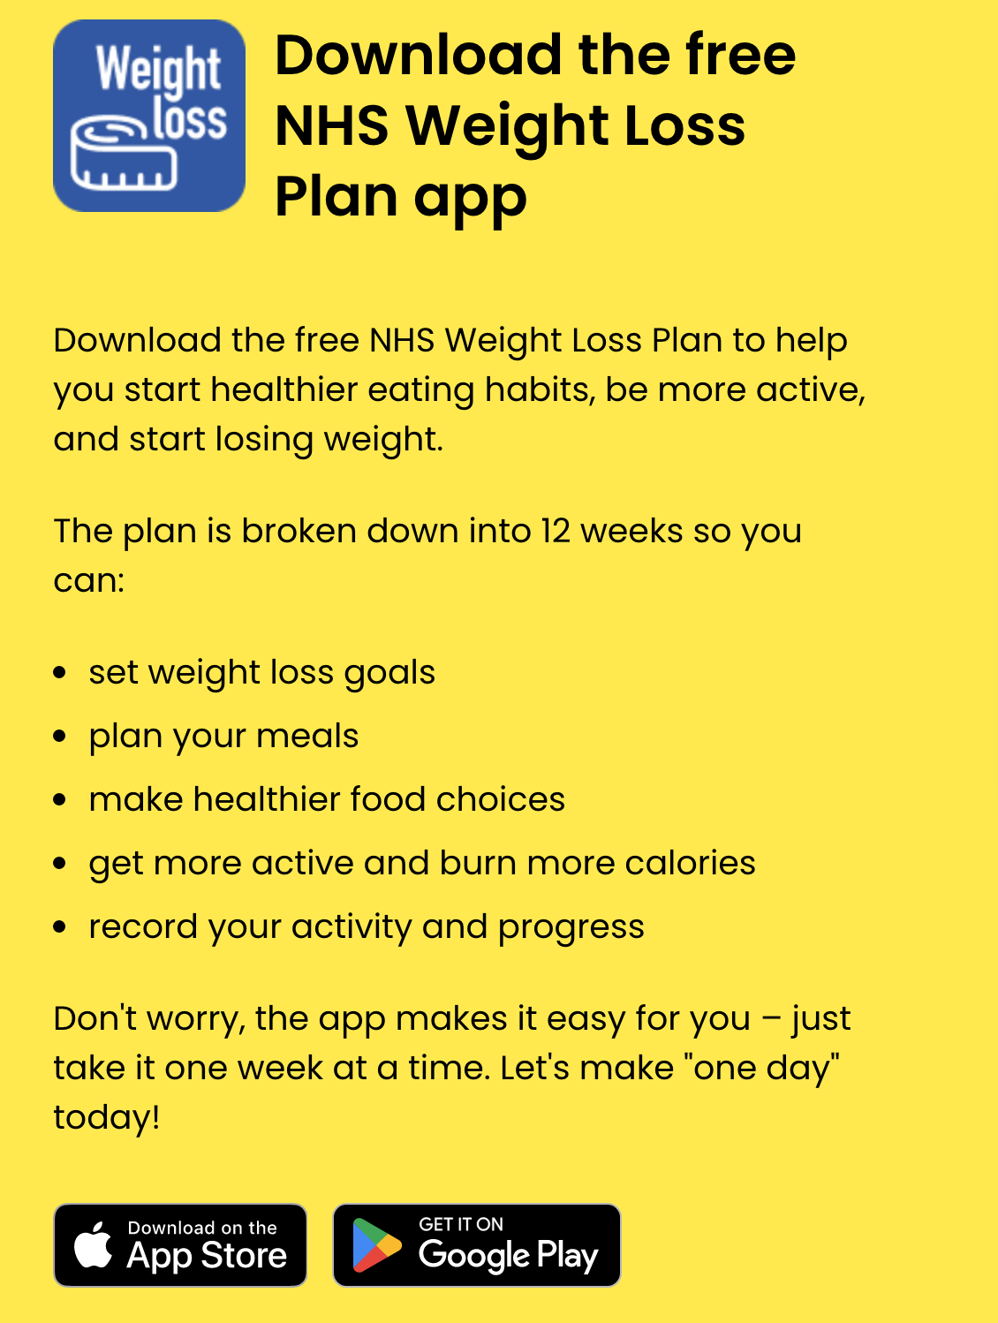
Visit the NHS Better Health website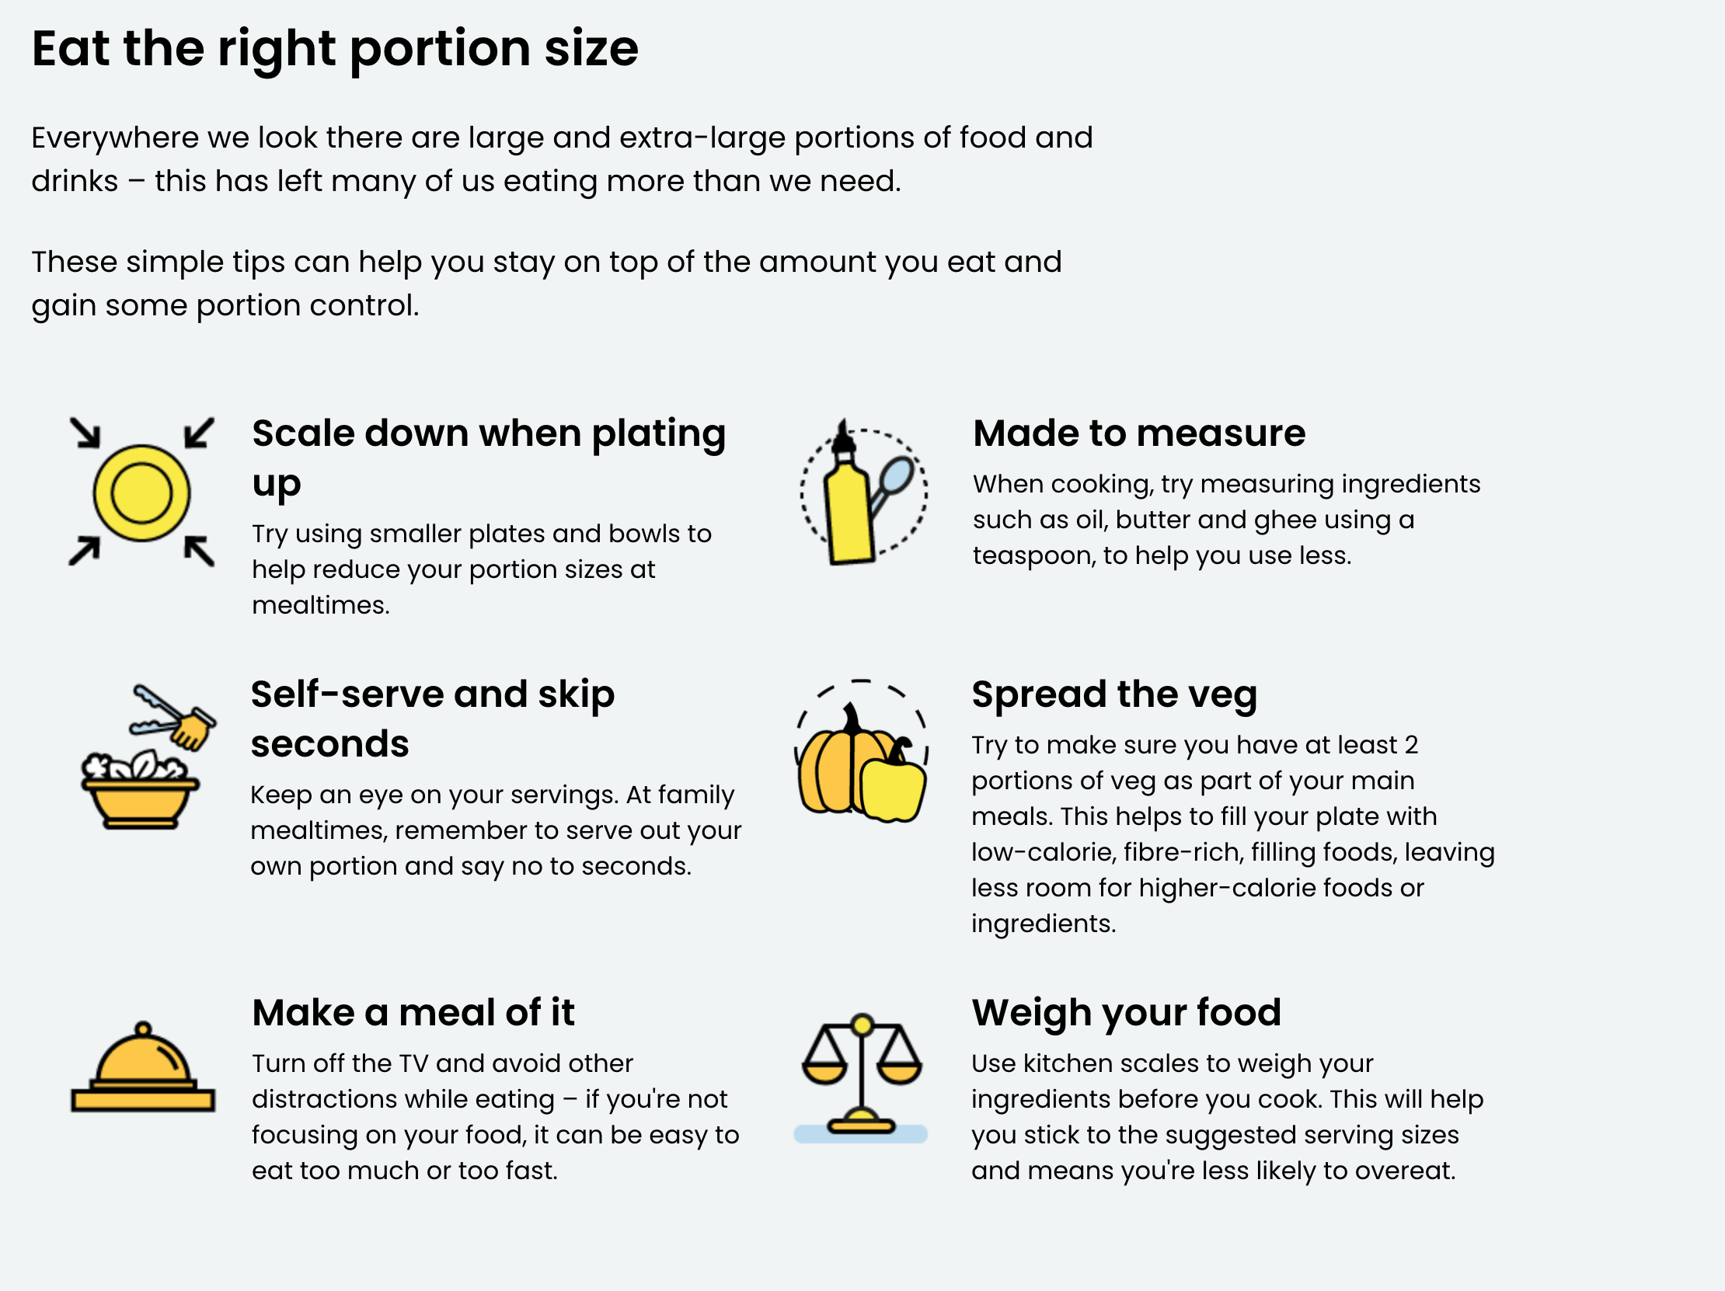
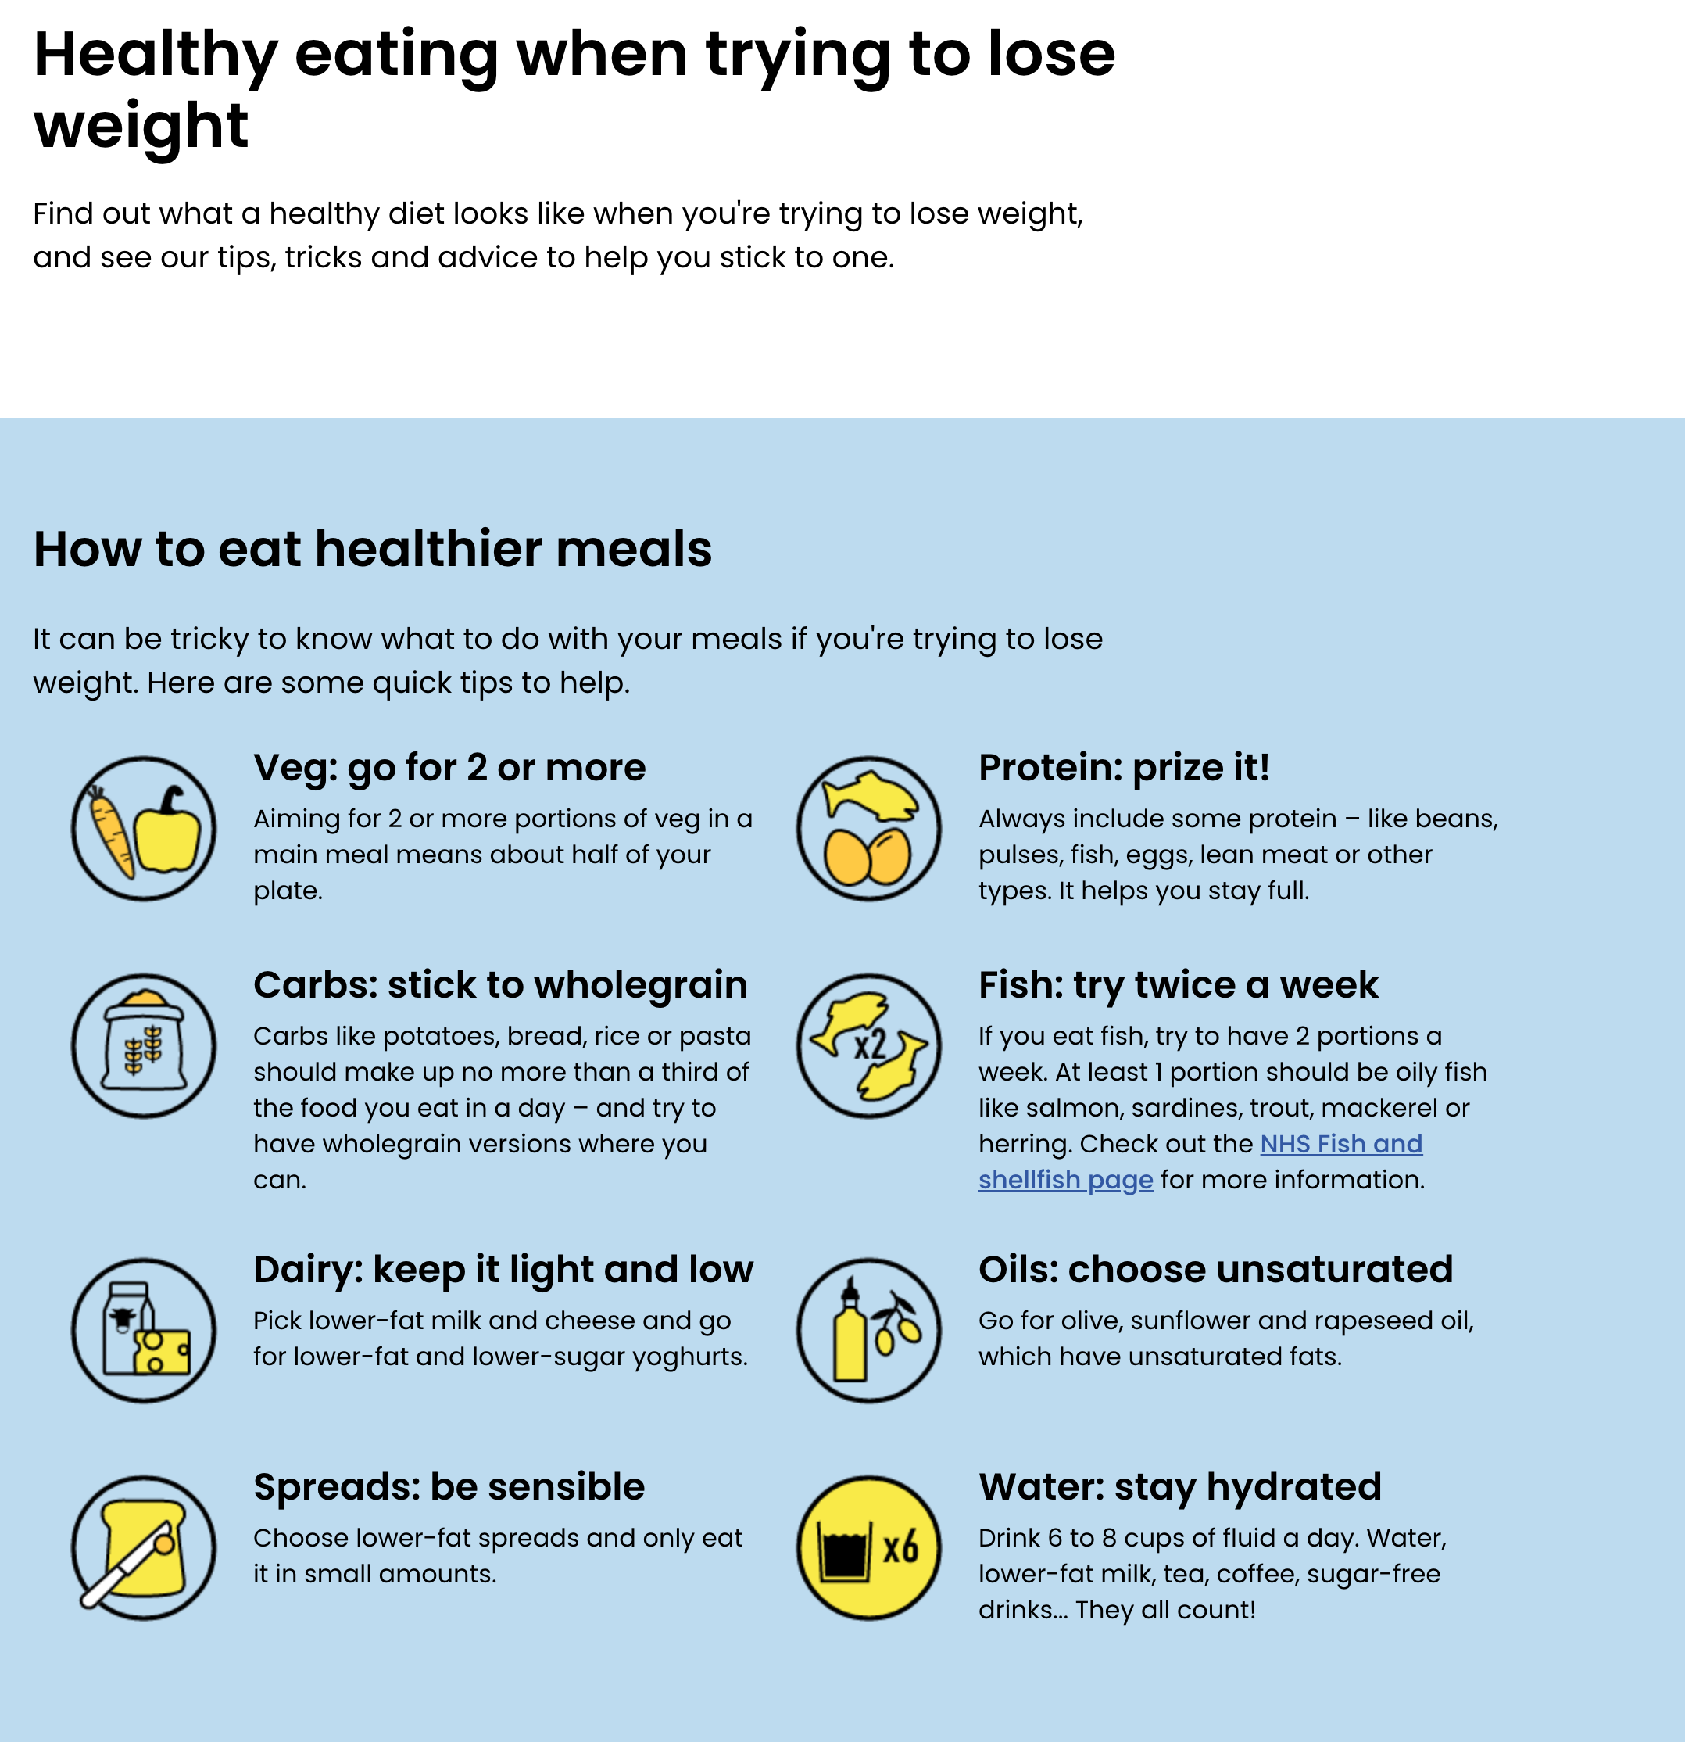
In fact the margarines, yoghurts etc that include plant sterols have been shown scientifically to improve your good cholesterol and reduce your bad cholesterol – but some of them are a bit pricey

Access over 100 healthy recipes
Filter by ingredient or time and find a new favourite for the whole family.
Visit the NHS Healthier Families website

Free NHS exercise videos
Follow an instructor-led workout from the comfort of your own home. Choose from dance, yoga and more.
NHS Fitness Studio
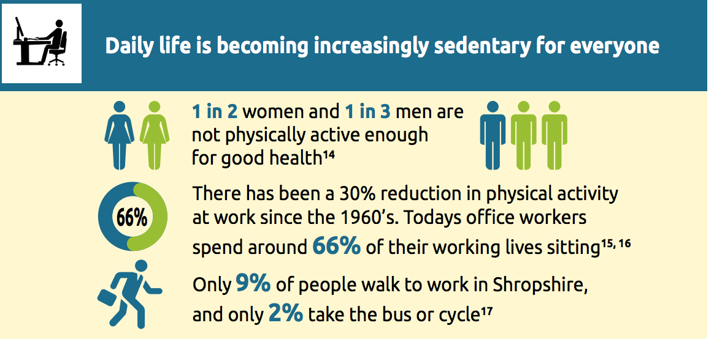
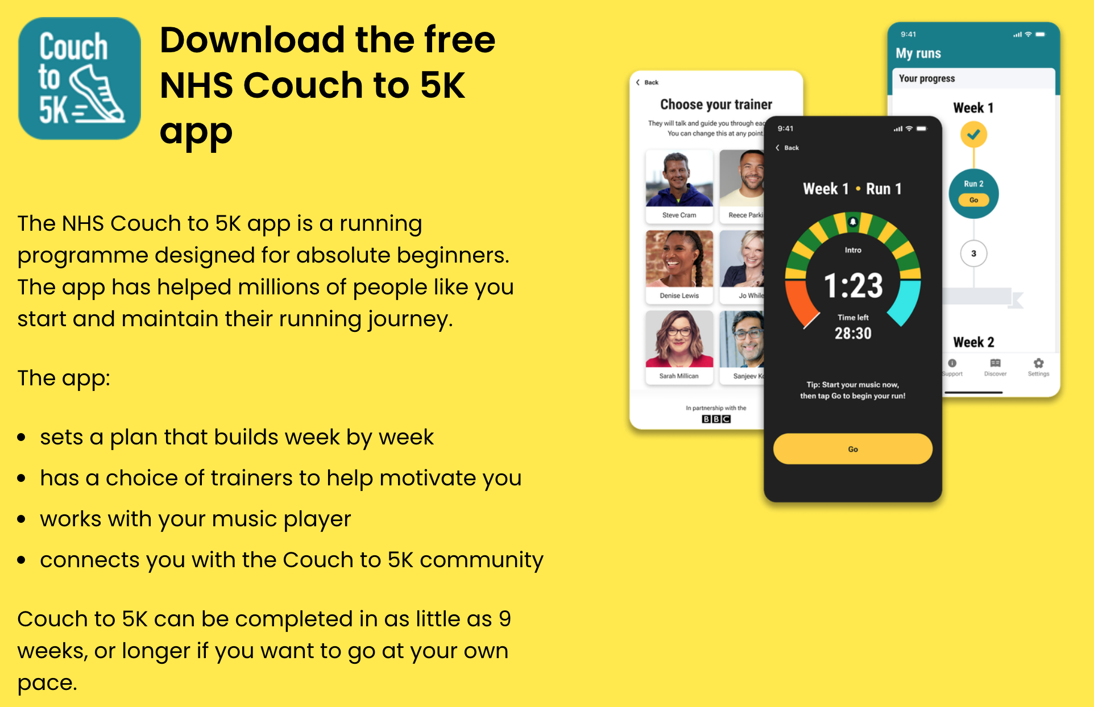

ABOUT WEIGHT LOSS MEDICATION

Please tell us if you are taking weight loss drugs so we can include this in your records
It is particularly important to tell us when:

You are on contraception as we may need to adjust the contraception to be healthy and effective; it may be worth considering a Mirena coil which can be fitted at our surgery by a nurse with 20 years of experience fitting them and training others to fit them

You are on HRT – the Progestogen part of HRT may need to be doubled orally, or patch or ideally mirena coil as its protective to endometrial cancer (which is obesity related)

You must tell your pre-op team if you are on weight loss drugs as they can affect gastric emptying/ anaesthetic drugs and so this could be potentially life-threatening

From NB Medical course:
Research independent of the drug companies making the drugs shows:
They work predominantly on brain to reduce hunger and increase satiety
They can act on hedonic hunger (pudding tummy)
They may well change body into a lipolysis (fat burning) mode

They benefit:
Cardiovascular health unrelated to weight loss – eg angina, heart failure, stroke
sleep apnoea
MASLD (fatty liver)
Chronic Kidney disease and Acute Kidney Injury
All cause mortality
They reduce inflammation – reduce cancer/ dementia
They reduce substance abuse of all types
They rebuild cartilage

Tirzepatide currently the most effective at losing weight – but the more effective the weight loss the higher the rebound of weight gain when you stop it so it could be that the cheaper semaglutide is actually the better option, long term

The effect of the drug varies depending on if they are a woman, less effective on men; on genetics, on menopause – it would be worthwhile being on HRT if menopausal, to help you lose weight

Side effects

Mainly GI and dose related – nausea, vomiting, diarrhoea, constipation – often lasts few days with dose increase – if longer then drop dose
Pancreatitis is not drug related

weight loss by any method increases gallstone production do beware RUQ pain esp if temp – surgeons ask if on this. 30% post bariatric surgery will develop gallstones

Eye problems –diabetic neuropathy if sudden change in HbA1C
loss vision 1 eye – urgent eye clinic
Oral contraception – change to non oral

They do NOT negatively effect strength but if low muscle mass because immobile or elderly when start them will need resistance exercise

Weight regain

This happens with all forms of weight loss because of hormonal changes
start to regain ++ but this does slow down

Maintenance

can continue on high dose
can reduce to fortnightly
can reduce to a lower dose
can stop entirely and restart when weight regain – no issue bodily, but this can be detrimental Mental health wise

What we can offer at Plas Ffynnon Medical Practice, and unfortunately the huge limitations of them too:
Counterweight Programme
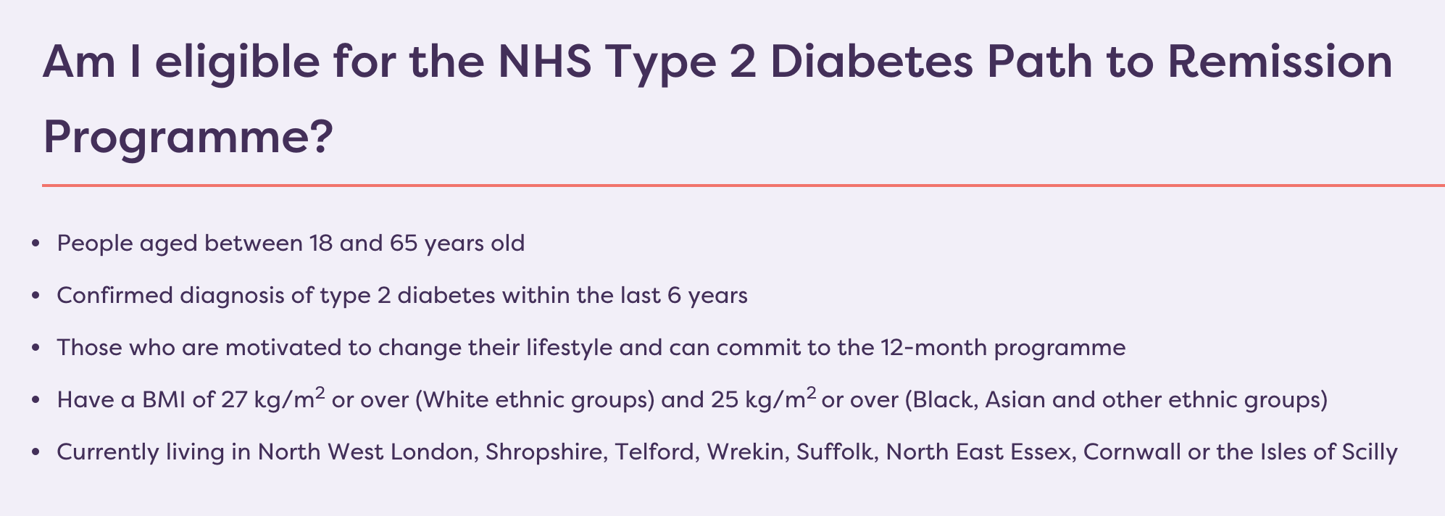
Tier 1 Weight Loss Management
NHS Digital Weight Management Programme
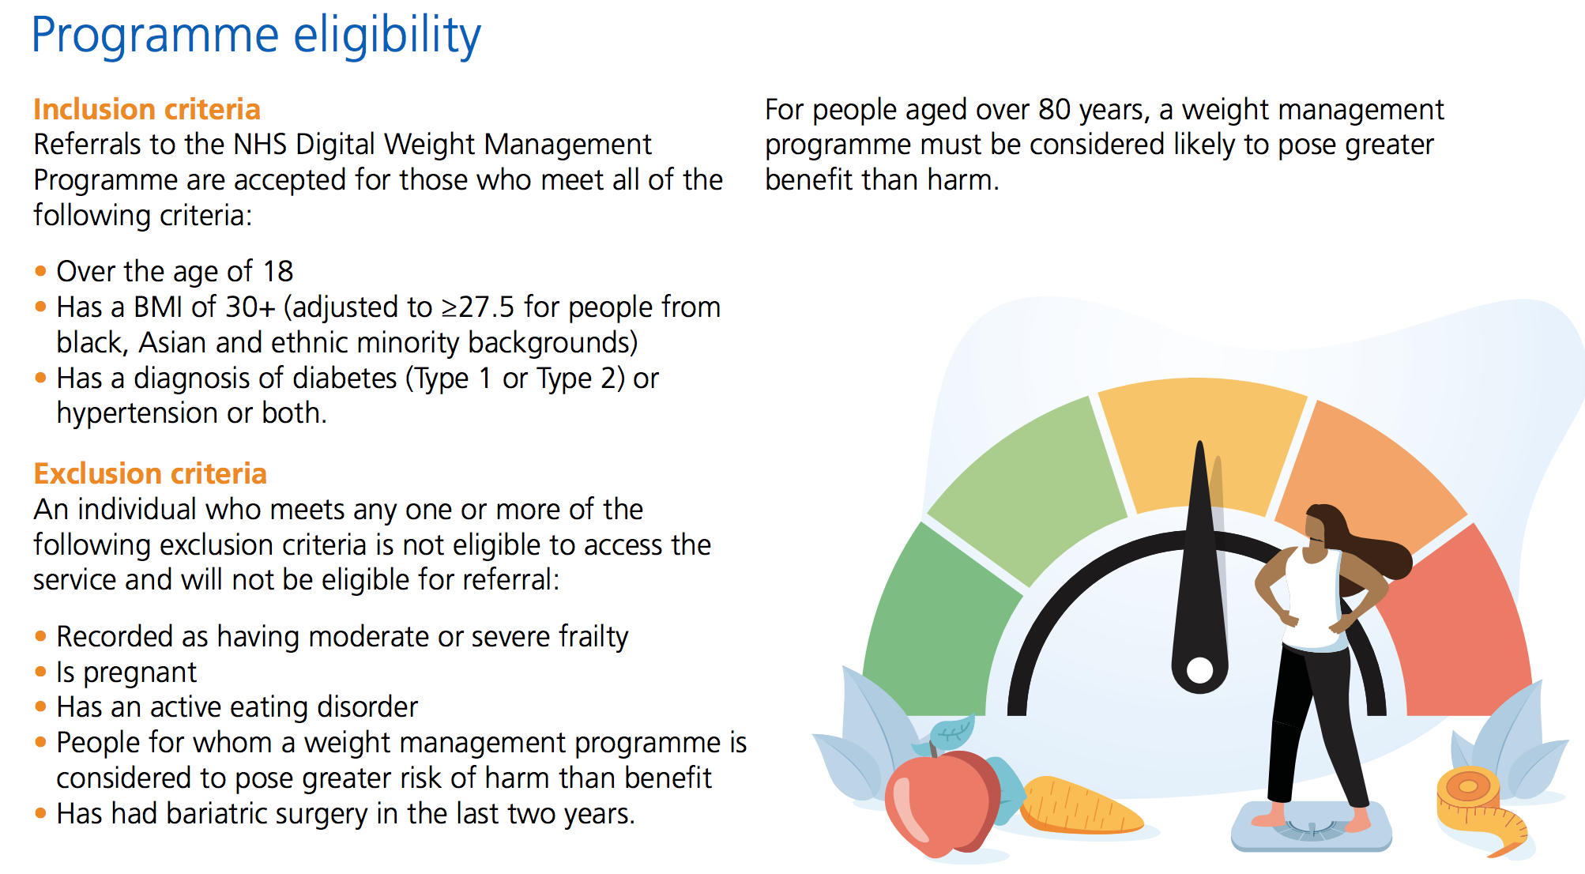
Tier 2 Weight Loss Management
OVIVA
A 12 week app-based digital service with 1-1 coaching from a dedicated coach. The programme offers personalised support with periods of self-led learning to achieve meaningful changes to their diet and lifestyle. The support can be carried out via a digital pathway (Oviva app) or a telephone pathway. To programme can help participants to: ● Lose weight ● Improve the quality of their diets ● Learn the importance of having healthy balanced meals ● Increase your confidence ● Self manage your well being effectively
Only available if:
Social Prescriber
Are you eligible for Mounjaro on the NHS?
Currently the criteria are extremely strict, but there is now a non-hospital based clinic which can see
If you have the following medical conditions:
Tier 3 Weight Loss Management

